2017 Holiday Special--Limited Time Offer

November 20-December 31, 2017 only

INDIA UNVEILED: Spirit, Tradition, People
by Robert Arnett
Internationally acclaimed, multi-award-winning “Best Book on India”
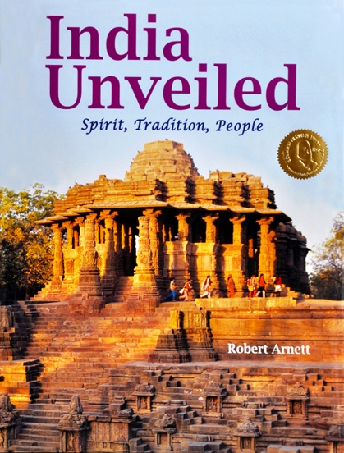
$38 each only (Retail and Amazon price $65)

Includes USPS media mail shipping
Add $7.95 for FedEx Ground shipping. All copies autographed.

307 color photographs on 170 gram Garda gloss art, acid-free paper

308 pages, 9.5 x 12.5 inches, includes timeline, glossary, and index
ISBN: 978-0965290098
************************************************************
Mailing address: Atman Press, 2104 Cherokee Ave., Columbus, GA 31906

Email: AtmanPress@Gmail.com Tel: 706-323-6377
Major credit cards accepted. Make checks payable to: Atman Press (GA residents add 8% tax)
For more information on the book visit www.AtmanPress.com

Orders must be received or postmarked between November 20-December 31, 2017

************************************************************
"The Best Book on India there is.”
Ambassador Ajit Kumar, India’s ambassador to the United Nations in Geneva, Switzerland

"Perfectly expressed truths and magnificent photos….[The upgraded] sixth edition of India Unveiled…is a must have for anyone who loves India and wants to share it with the world.” Hinduism Today

Read the entire review online at: http://www.hinduismtoday.com/modules/smartsection/item.php?itemid=5612

